I use React to be the client side and node.js express to be server side.

Install instructions

Download it from the github

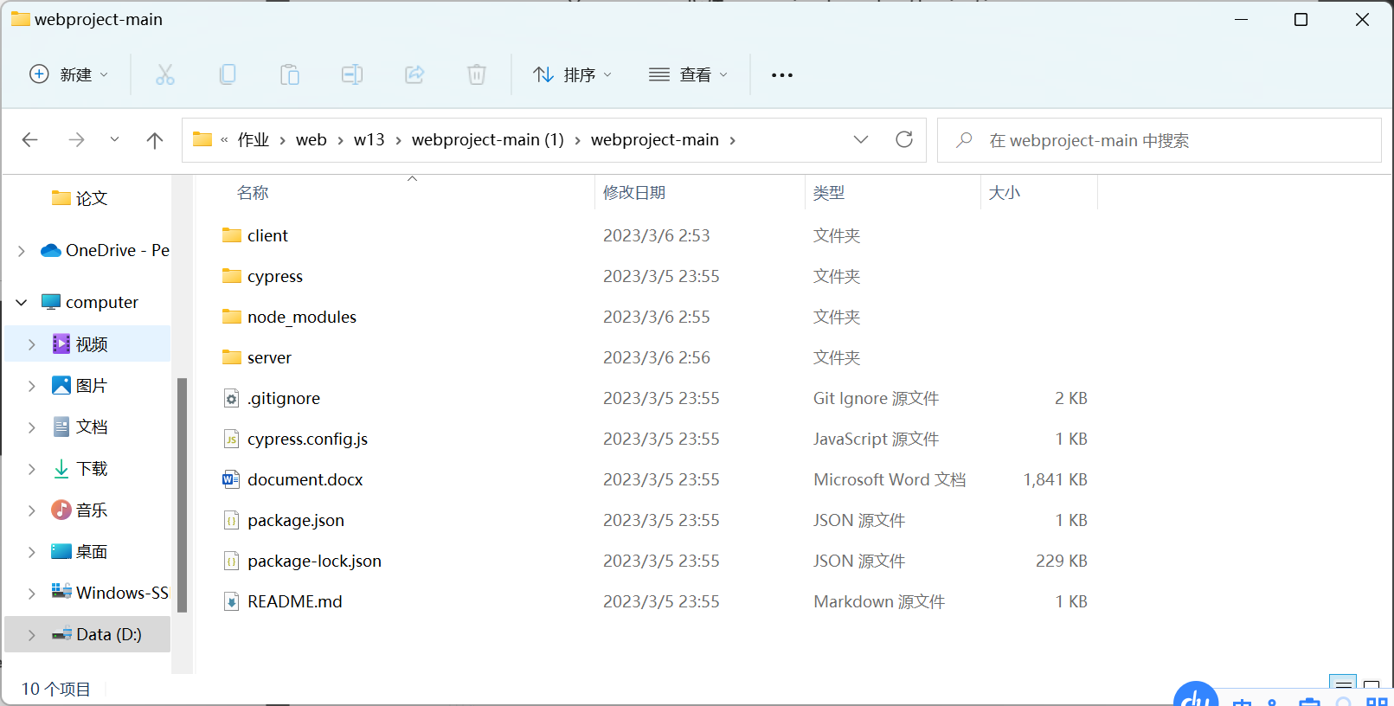

Open in this page in vscode

Install npm in

Run “npm i” here









To run this project, you need to run “npm run dev:client” in terminal

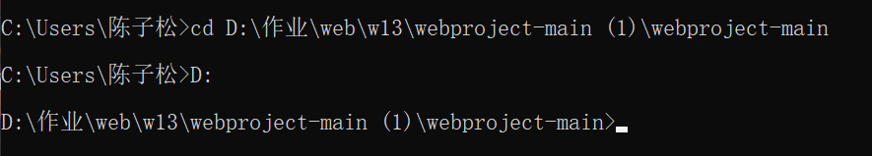

And run npm run dev:server in cmd



Then you will find it: 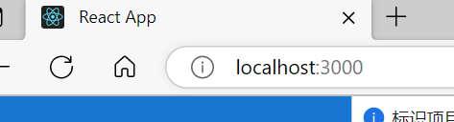

You can see a header you can use it to go to the page you want



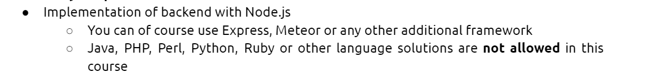

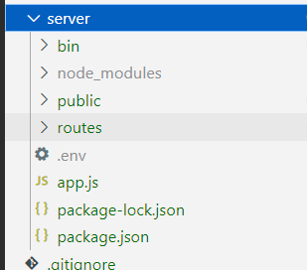





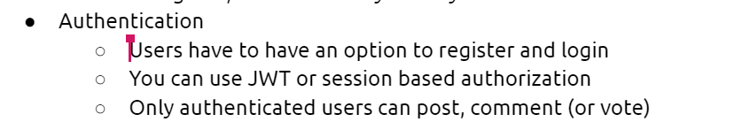

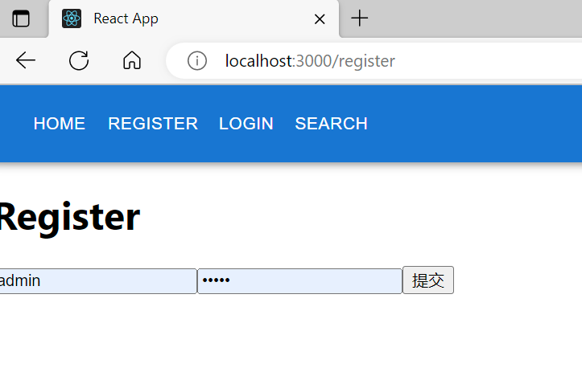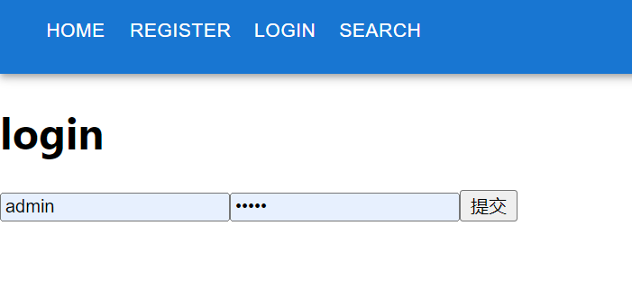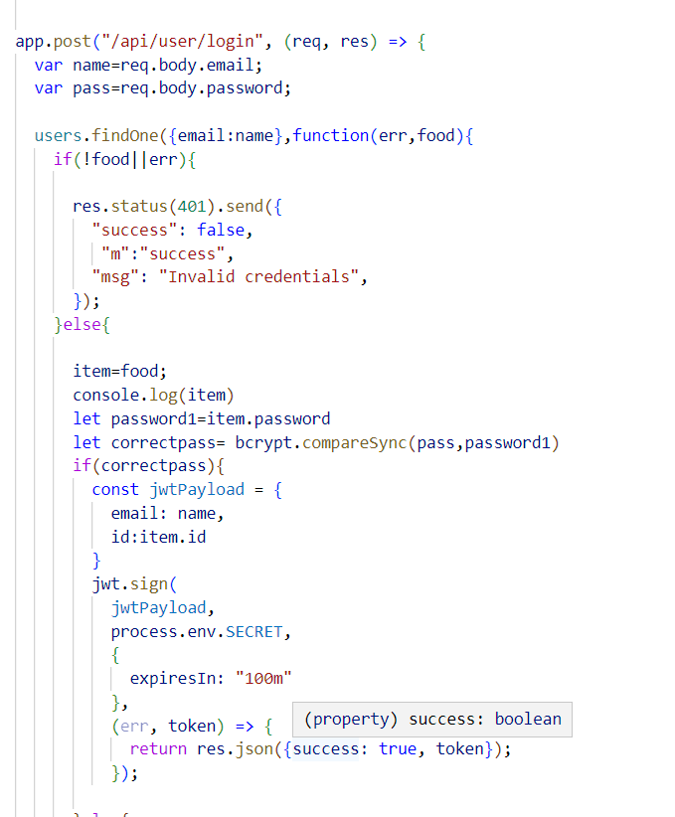

The use of jwt

Prohibit posting and commenting without being logged in

But you can see posts in Home page and see comments by press the "view comments” in each post to see related comments

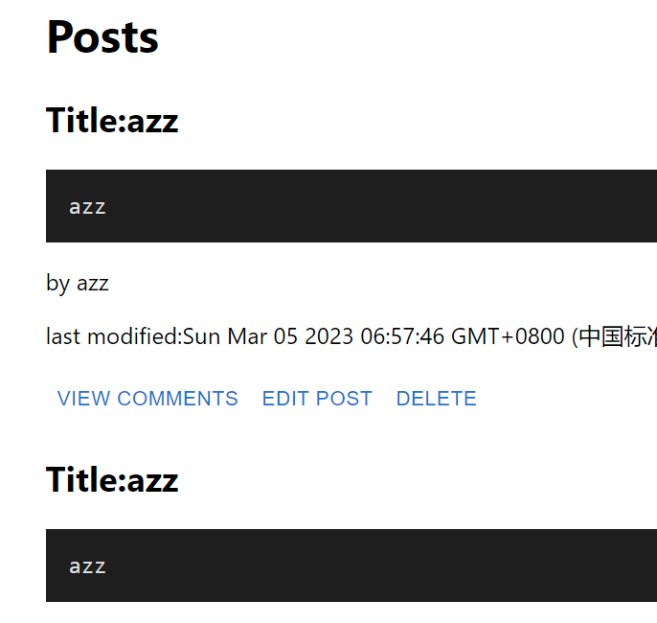

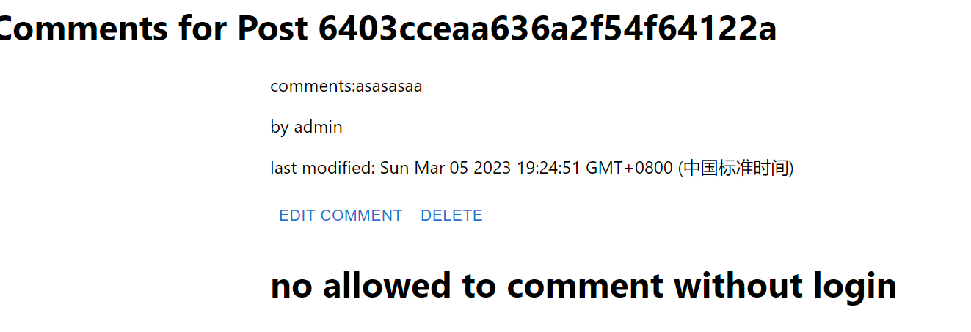

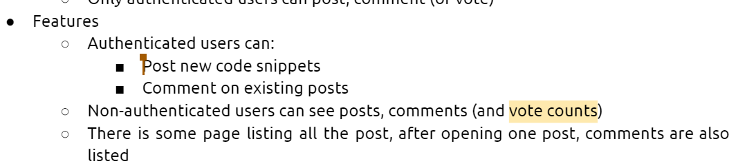

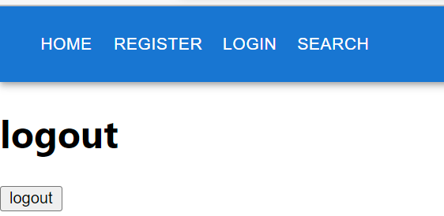

When you login, you can post in the end of “home” page and comment in “view comment”

Comment: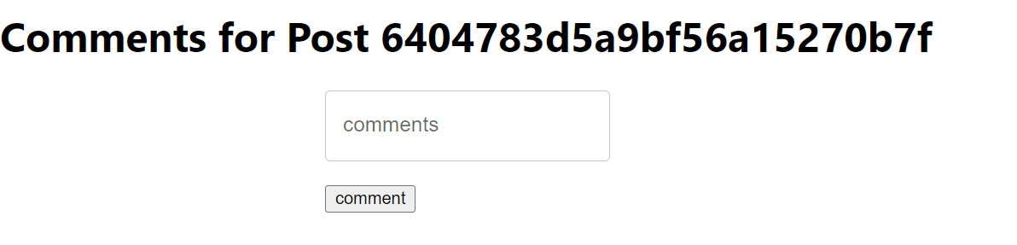post:

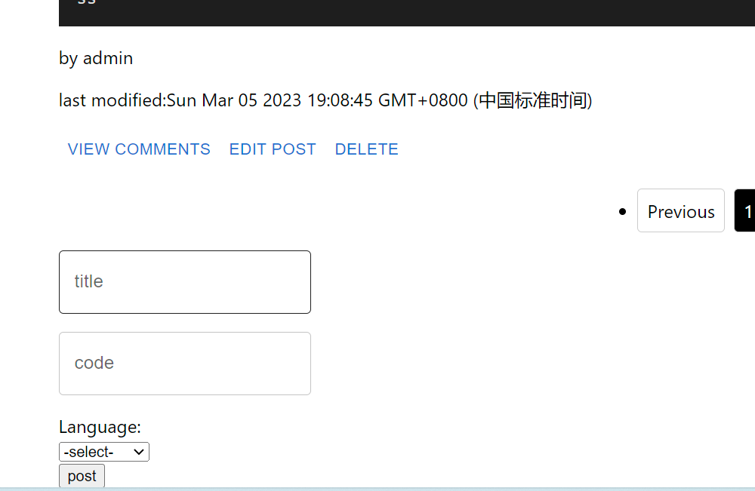

All posts are listed in “home” page

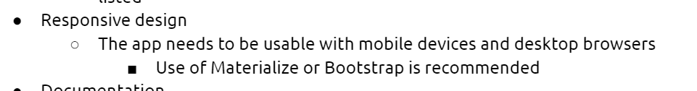

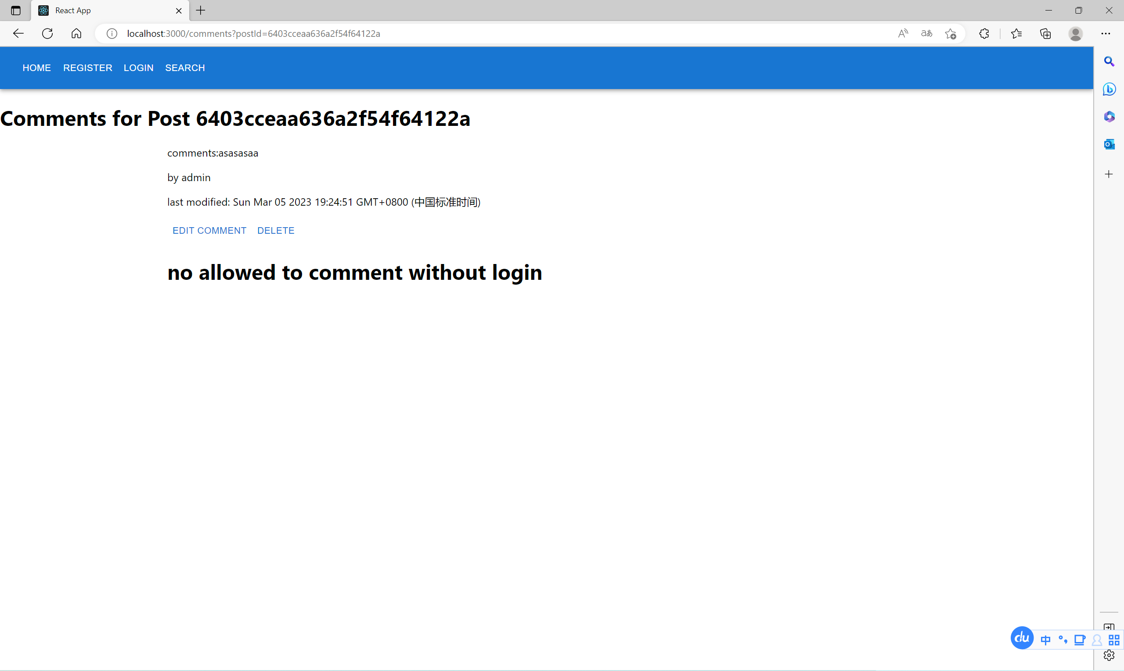

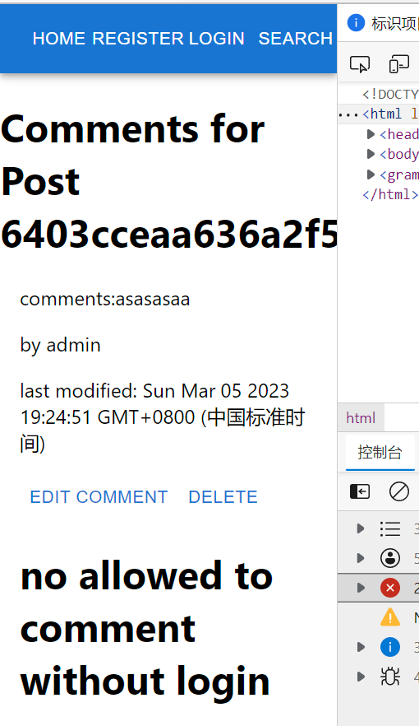



So far, we finish the basic part to get 25 points. Sum=25



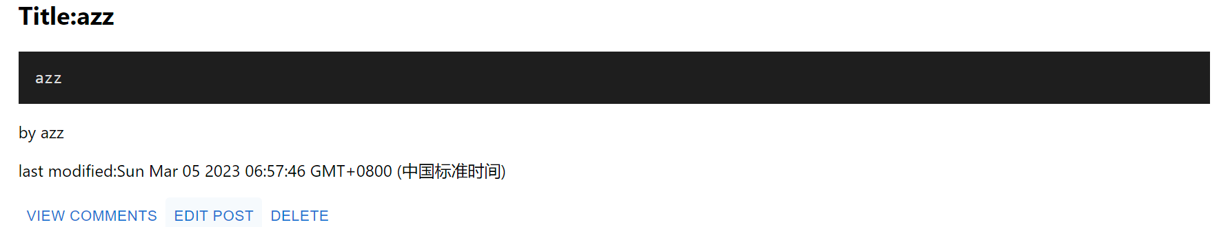

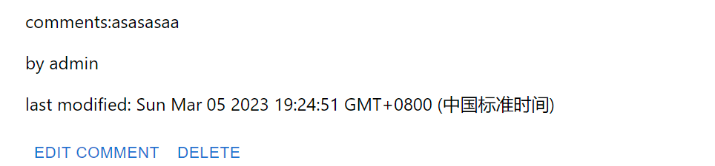

You can press ‘edit post’ and ‘edit comment’ to type the new content and title

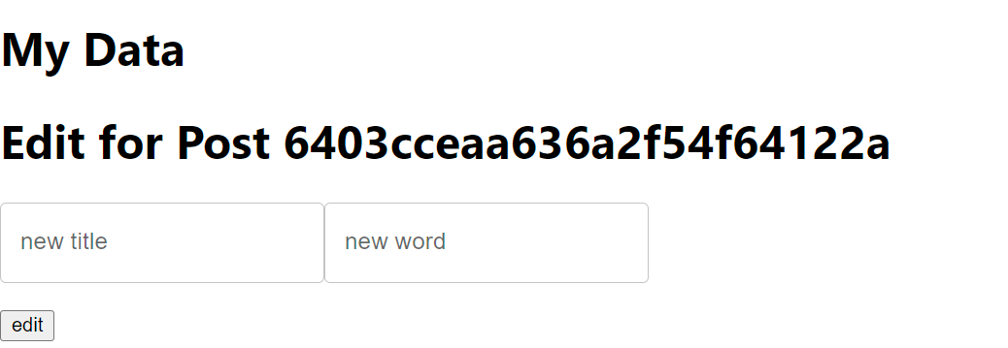

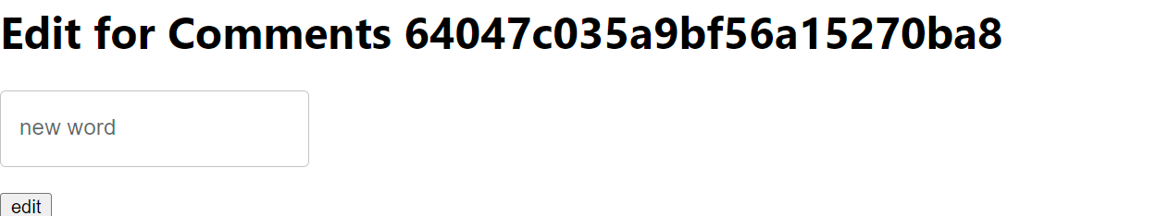

But you are not allow to edit when you are not login

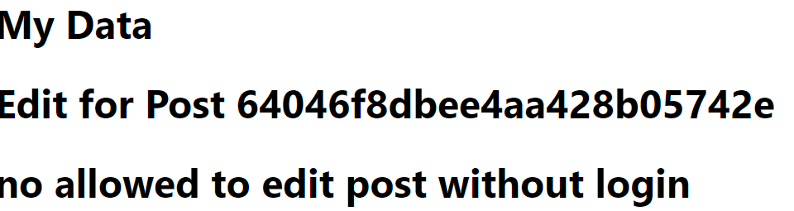 

And if you are not the owner of post and comment you are not allowed to edit.(unless you are the admin account)

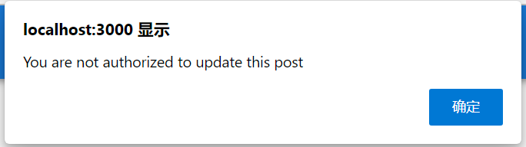 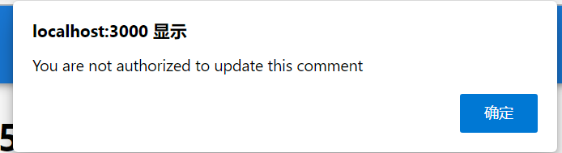

Sum =25+4=29



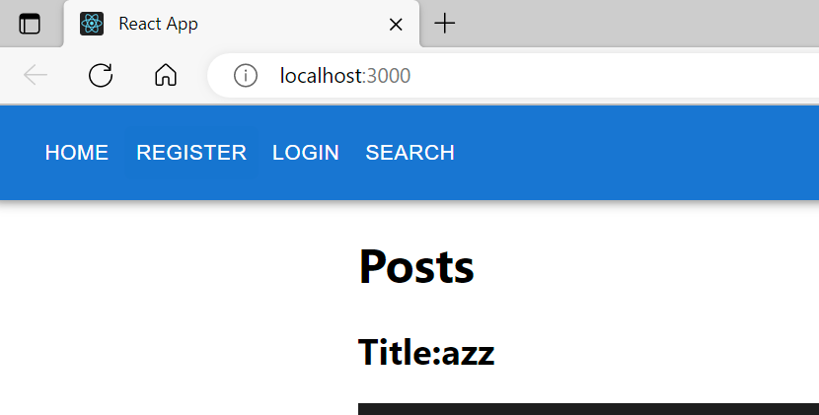 

You can easily find I use React in client side

Sum=25+4+5=34

Now you can see the



Then I use React in my client side.

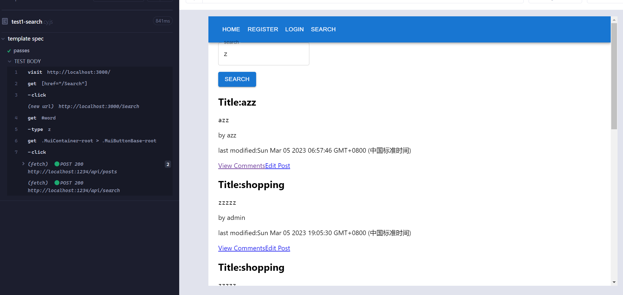

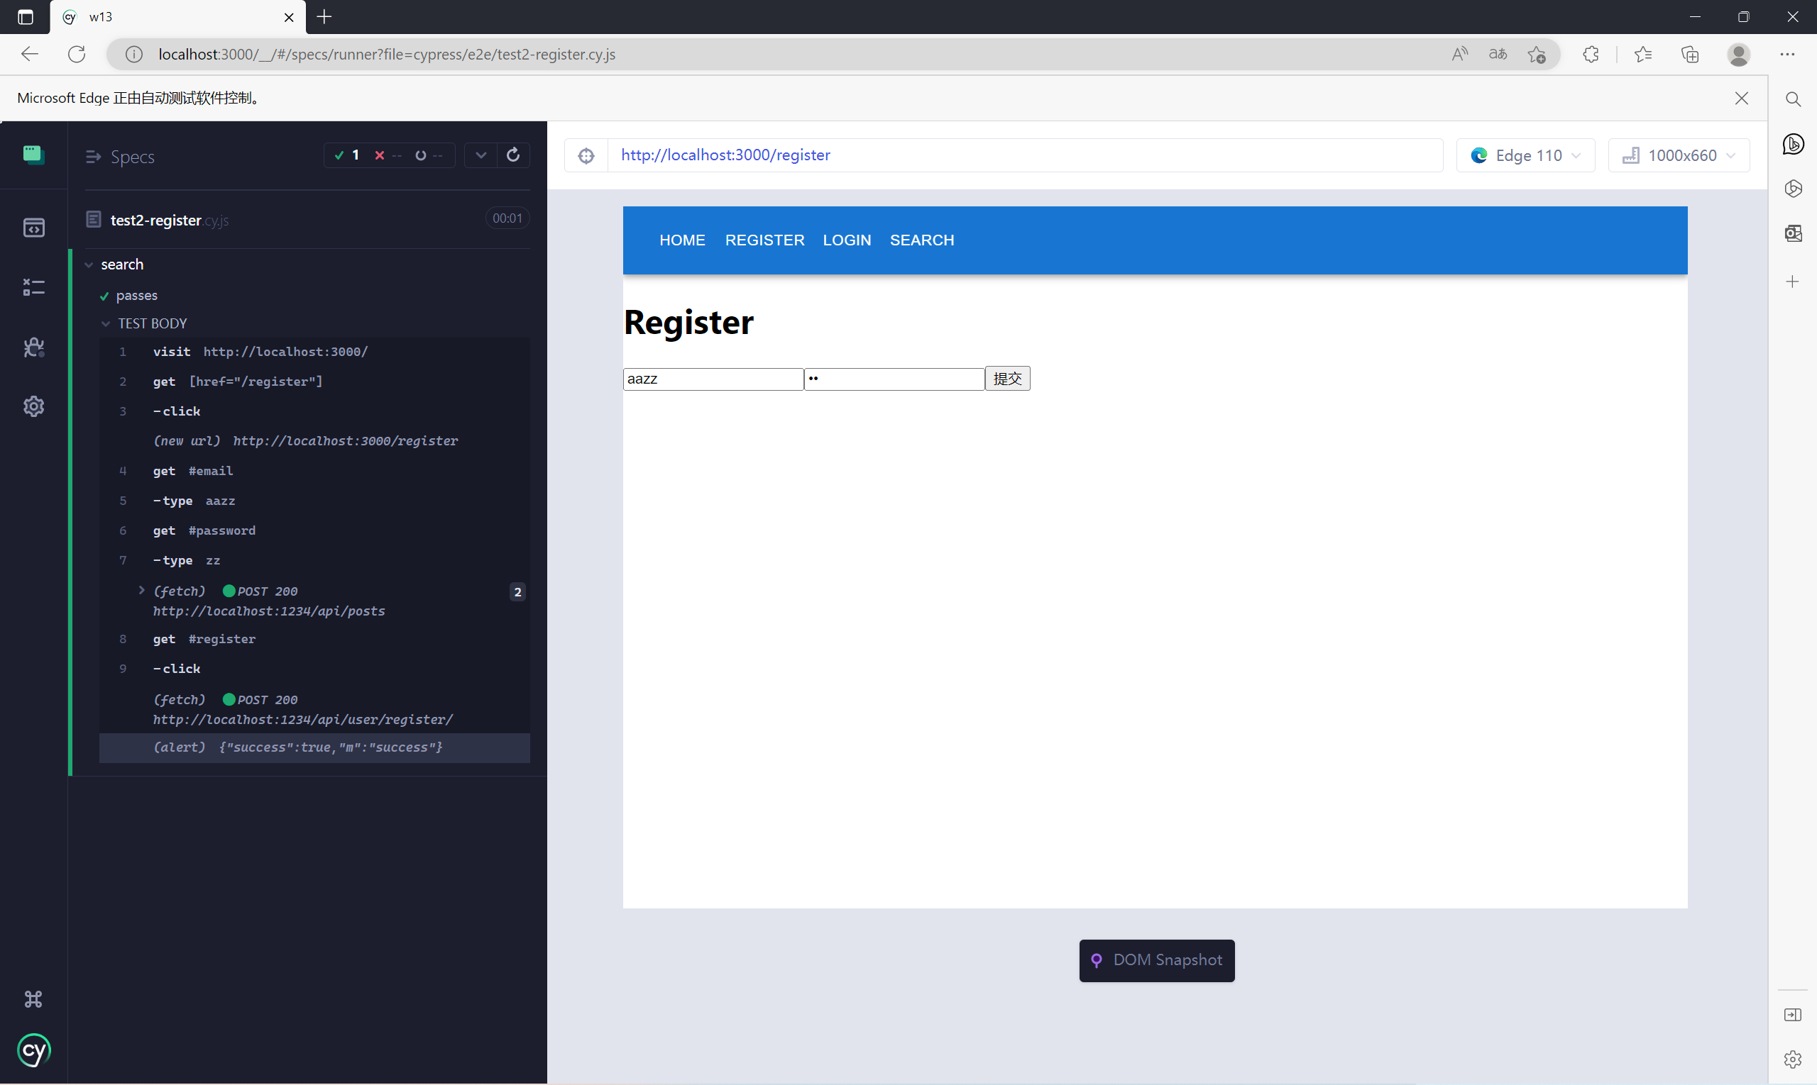

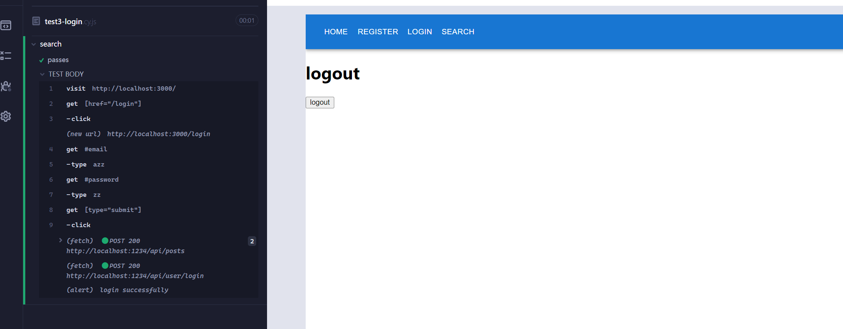

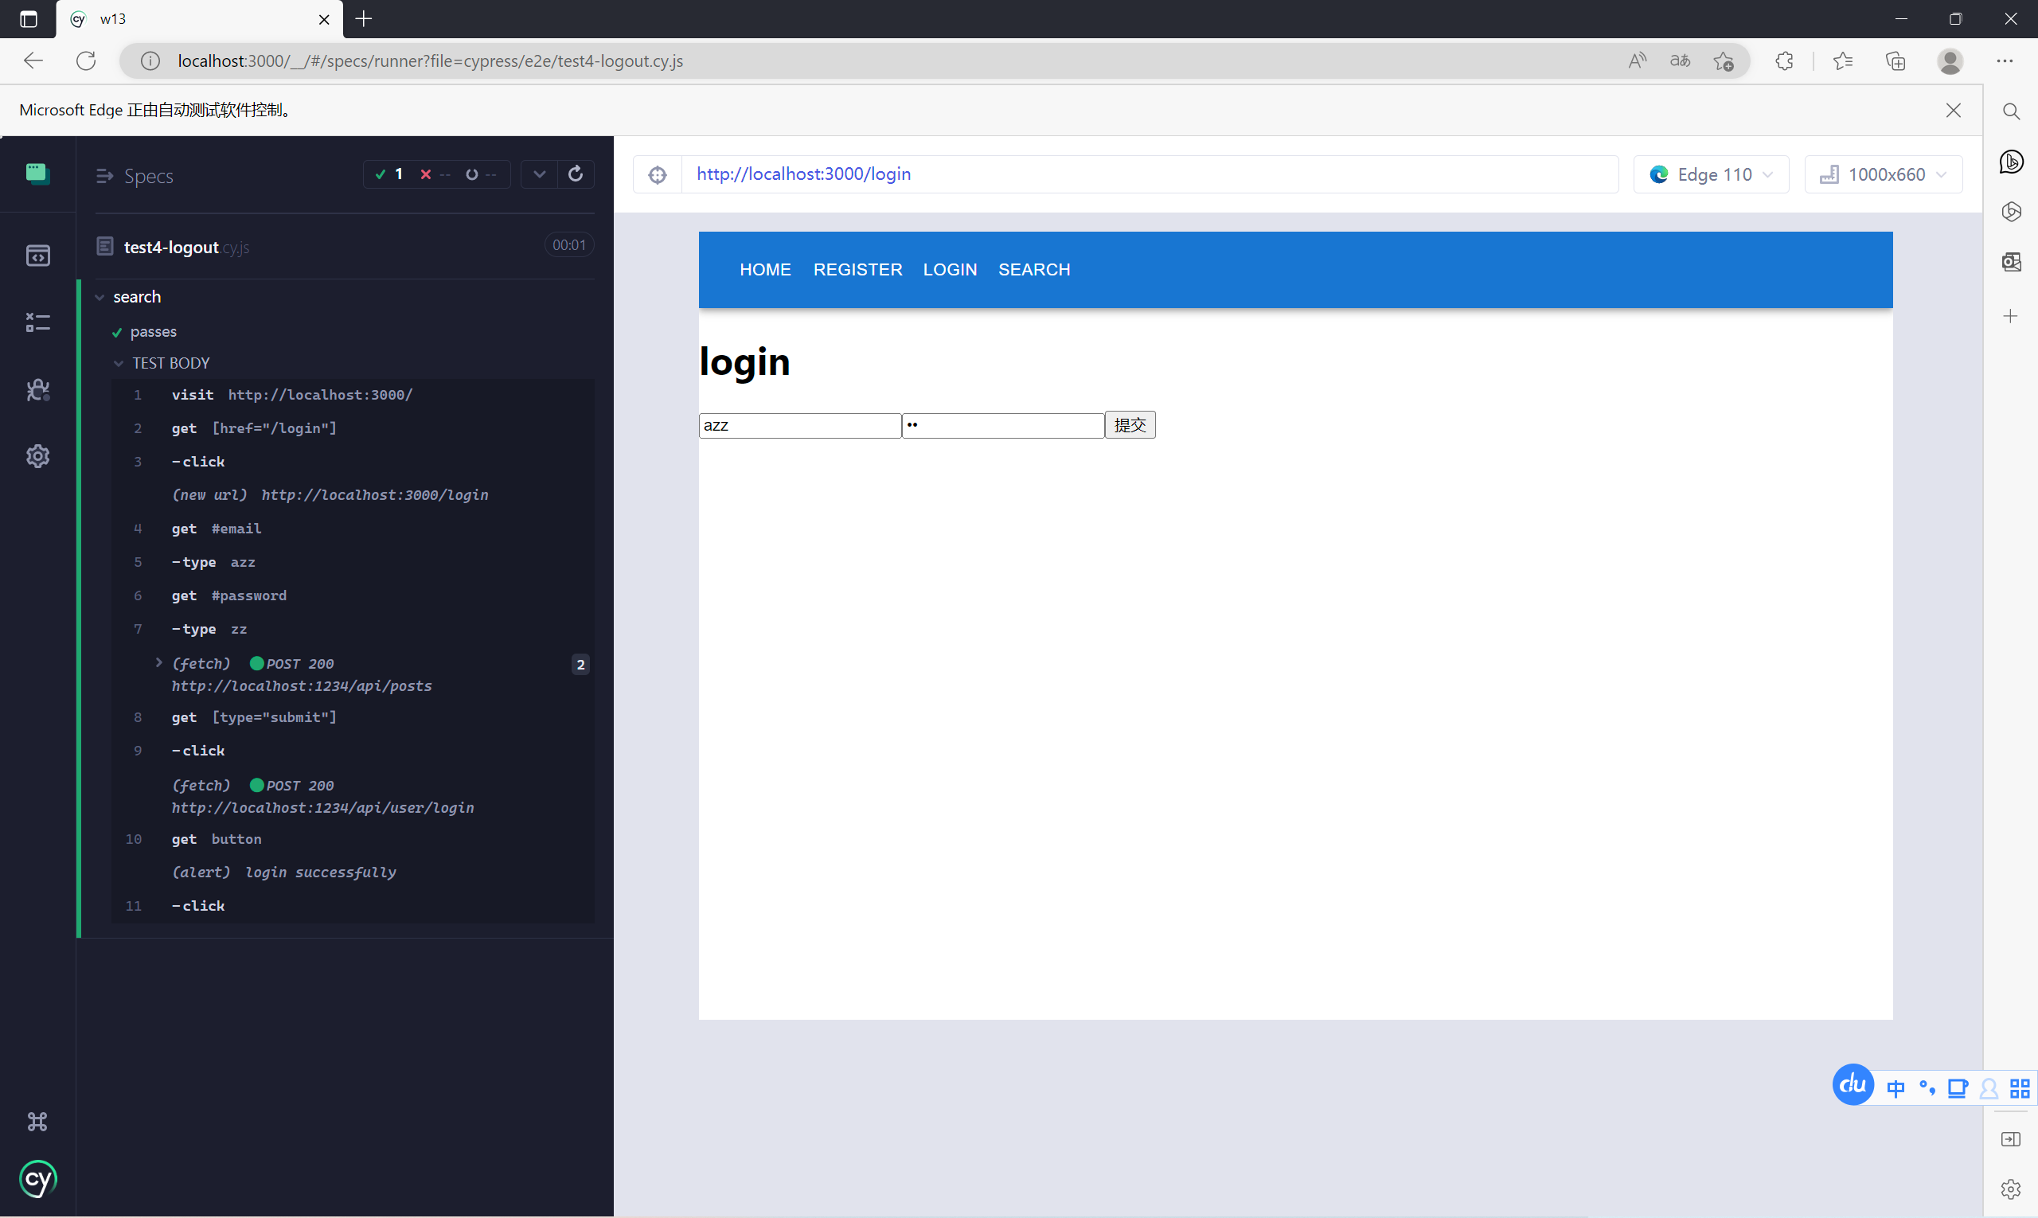

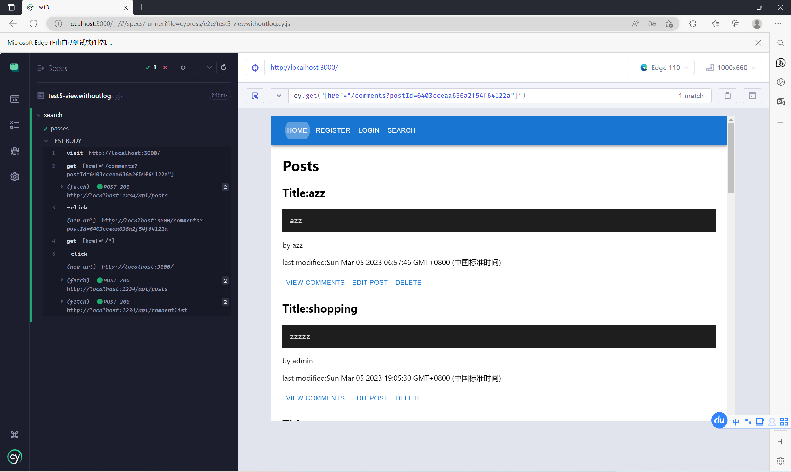

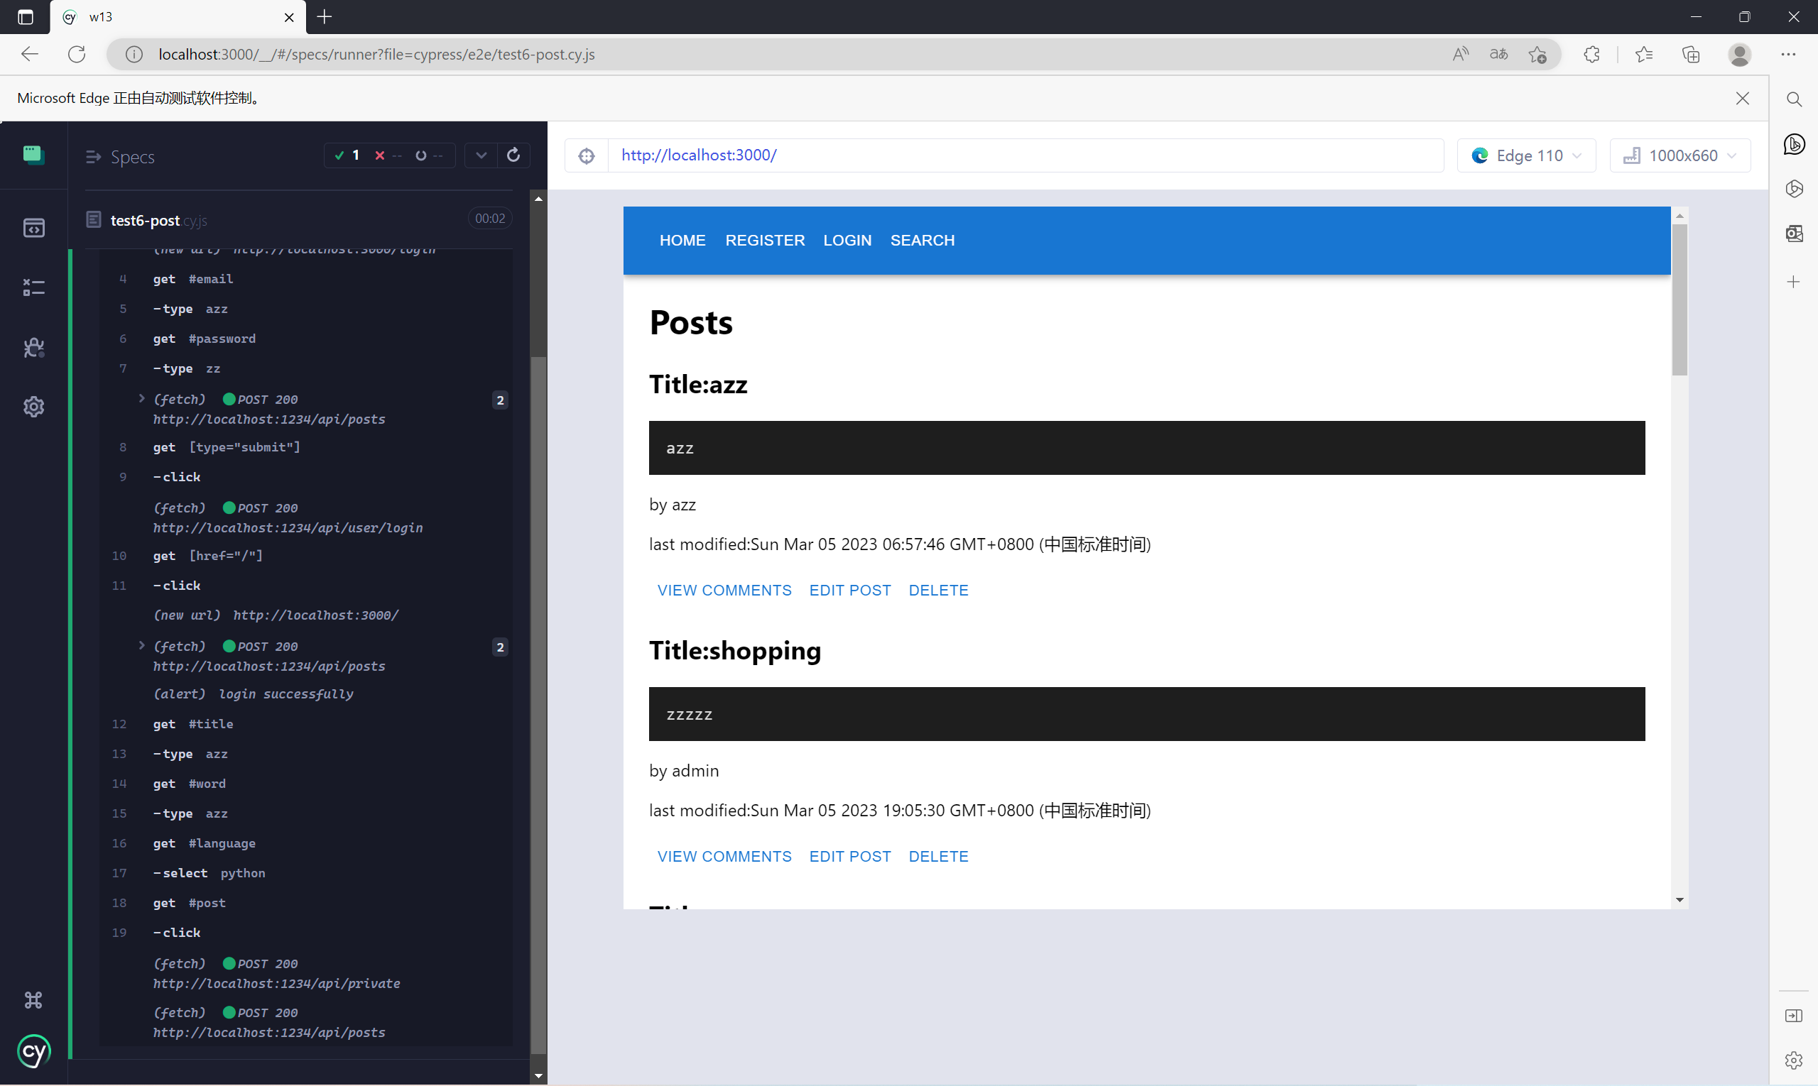

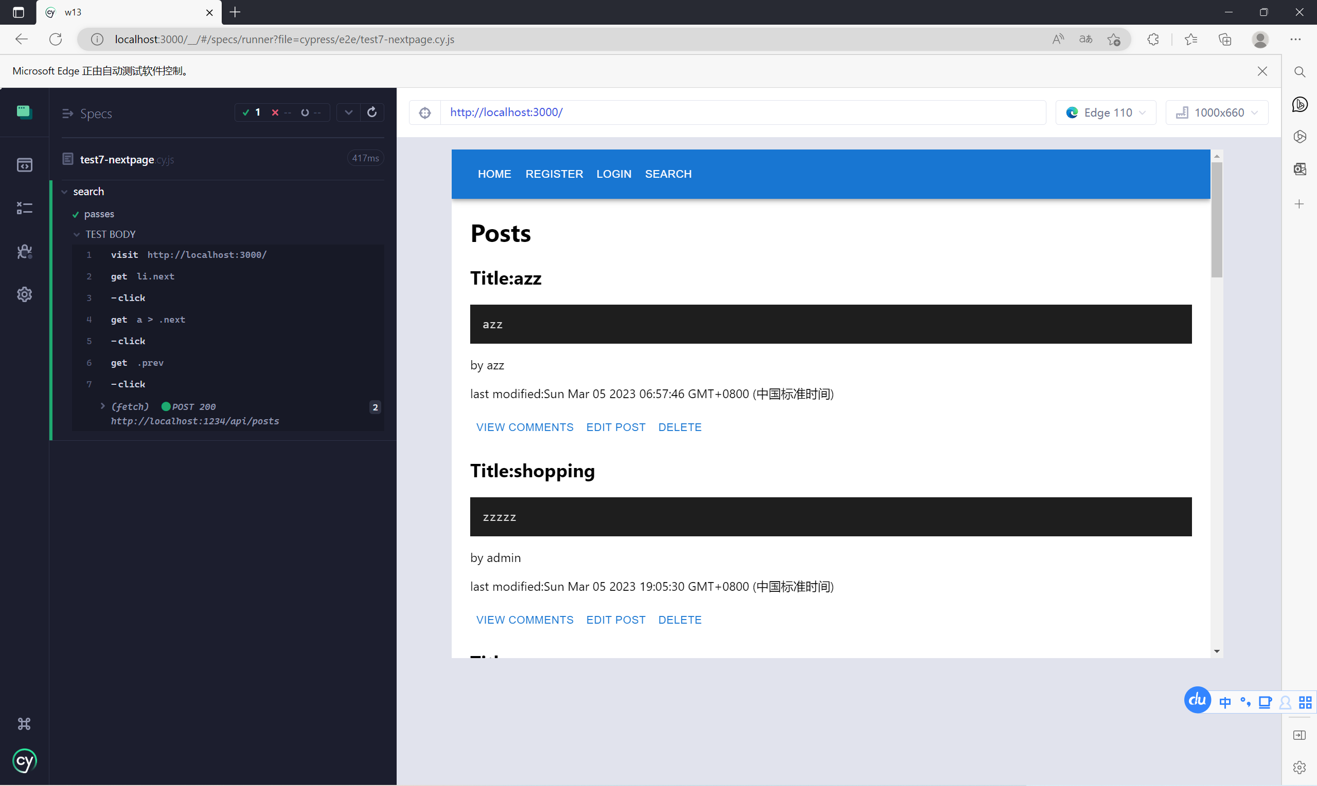

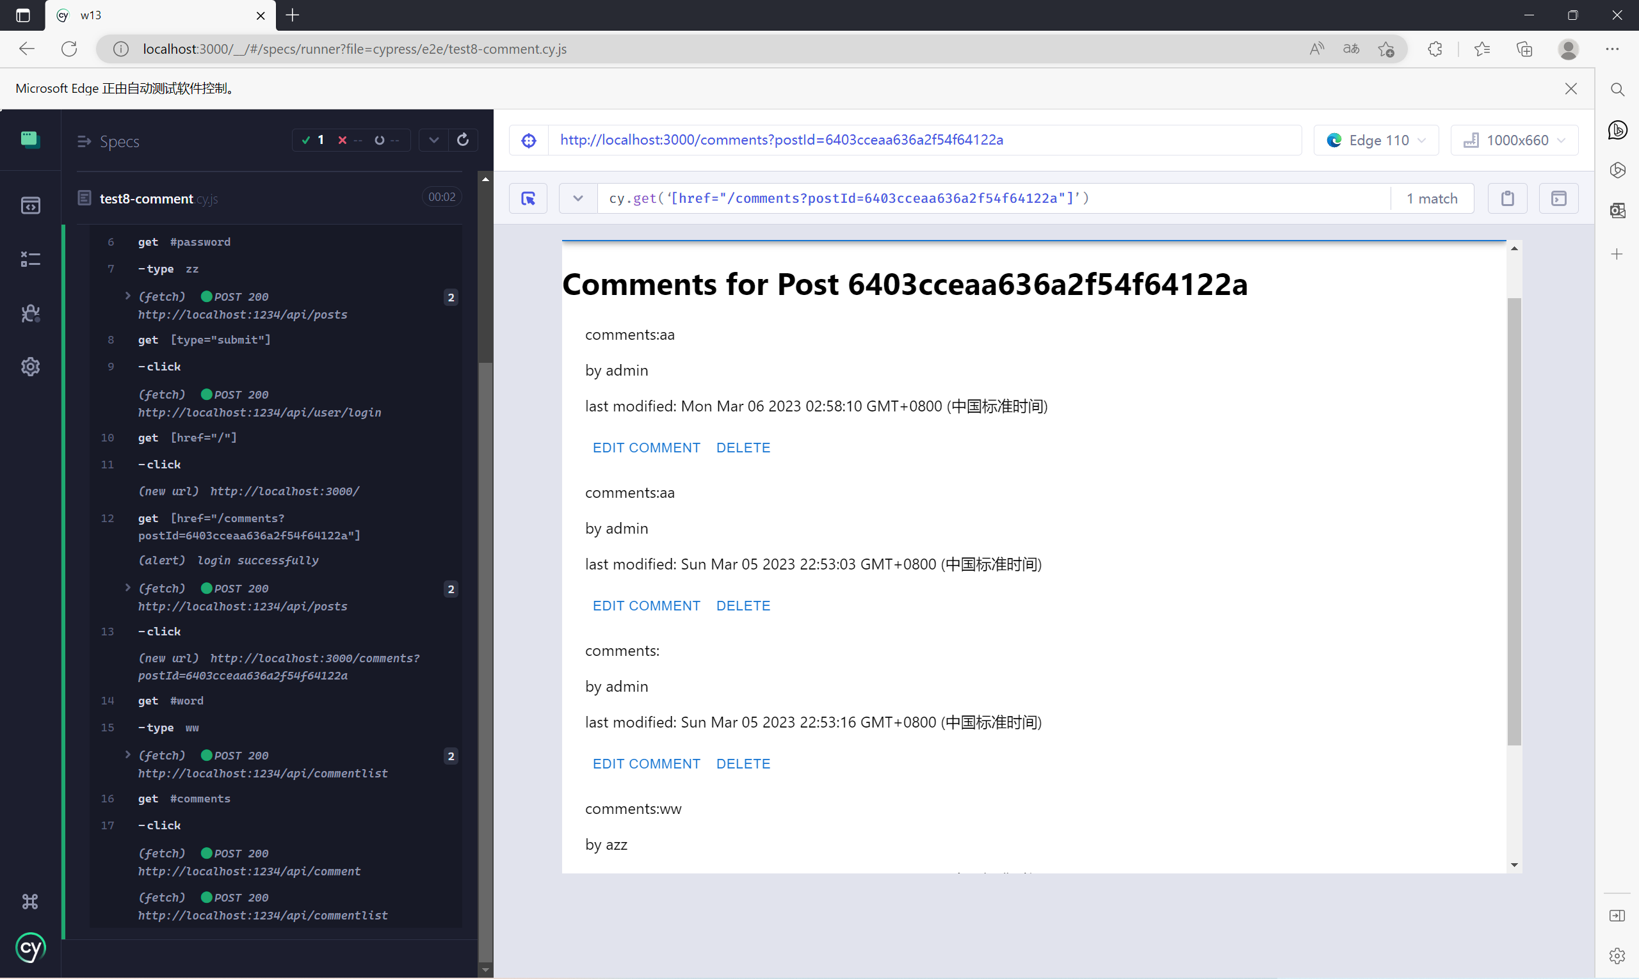

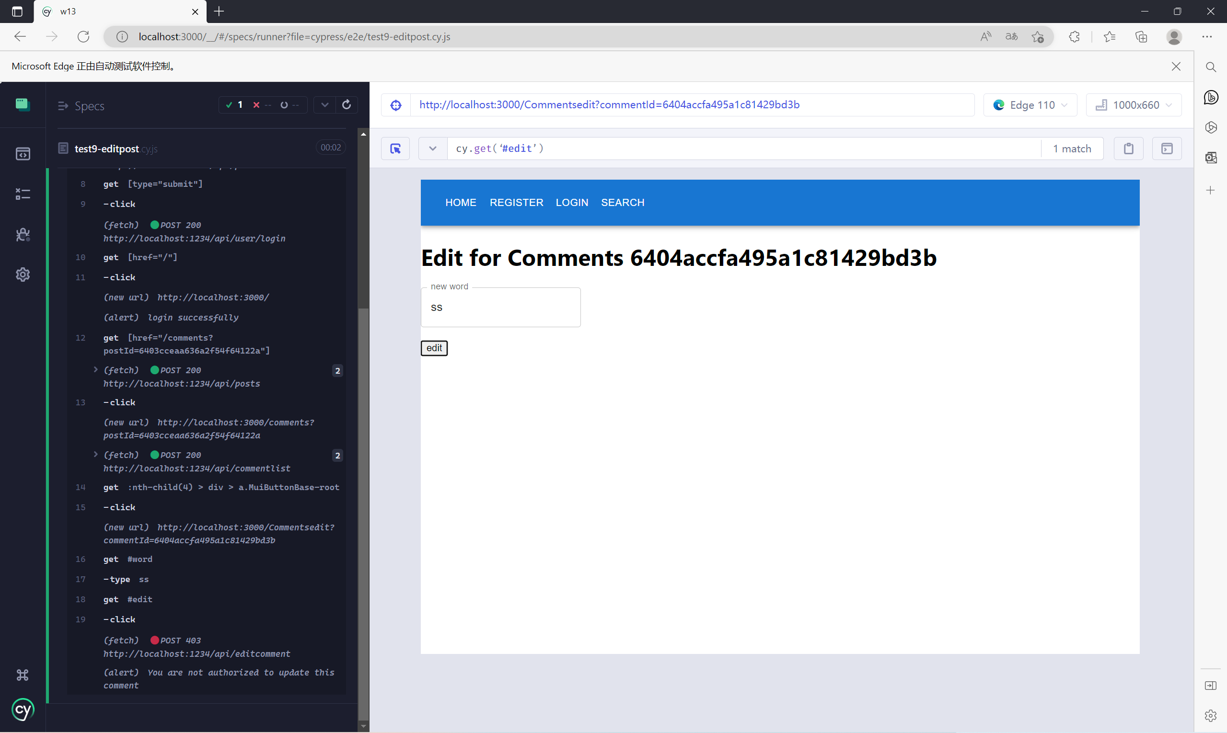

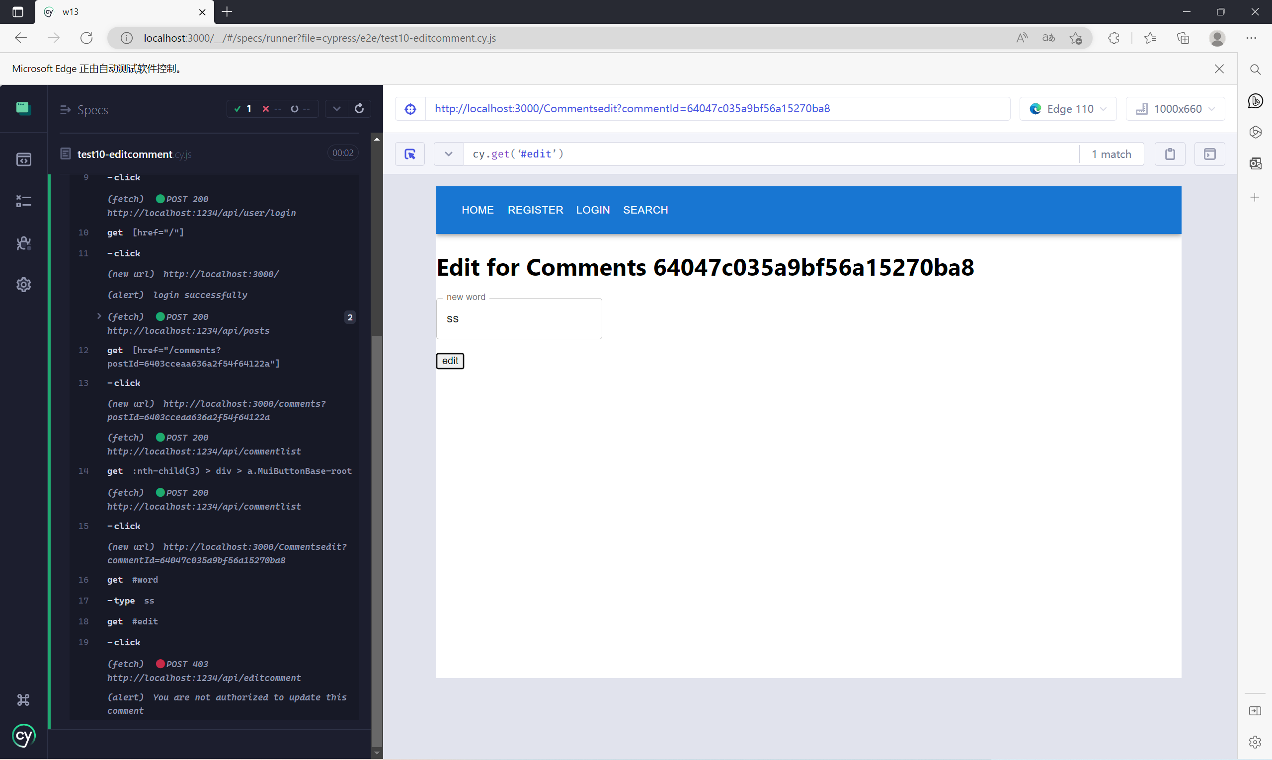

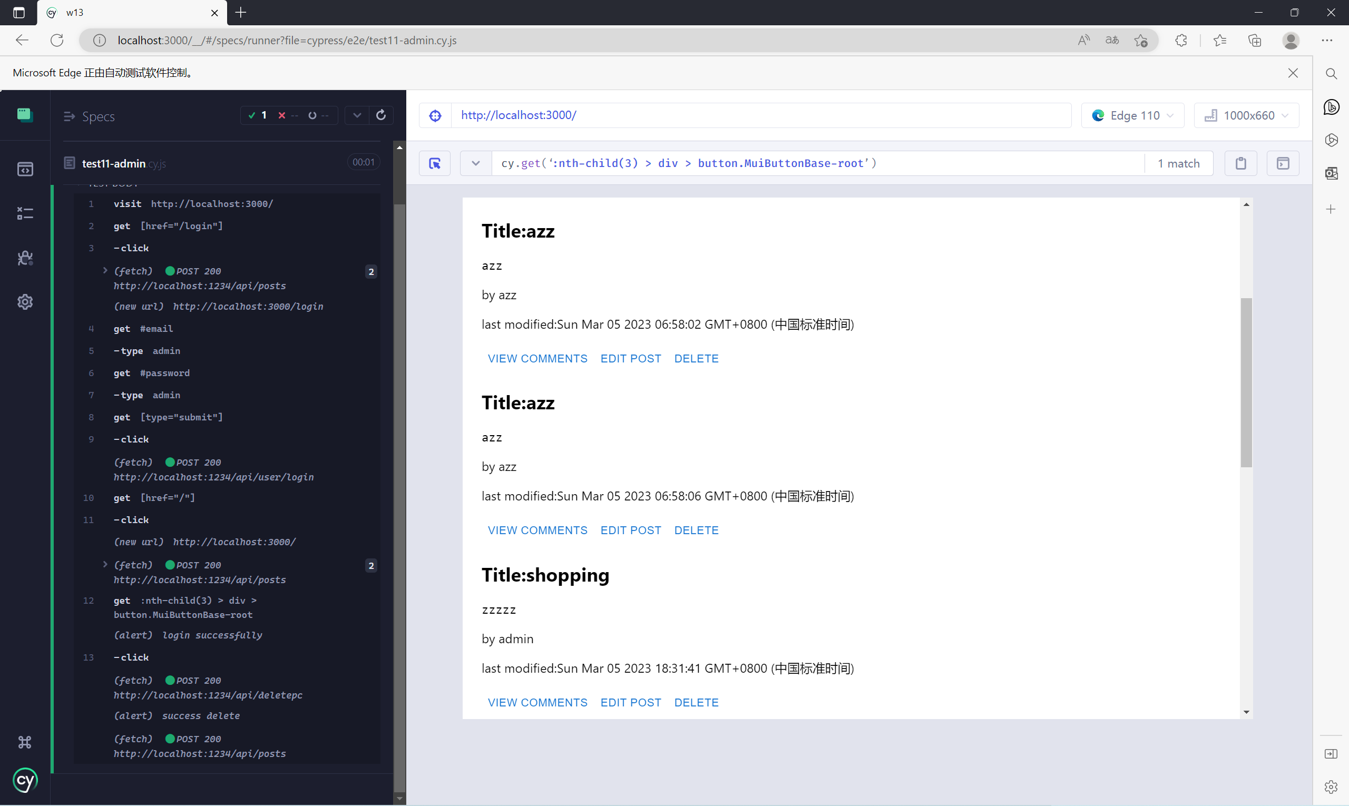

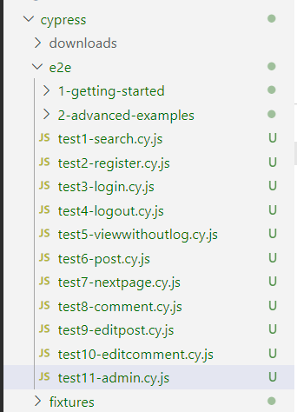there are the 11 tests I done

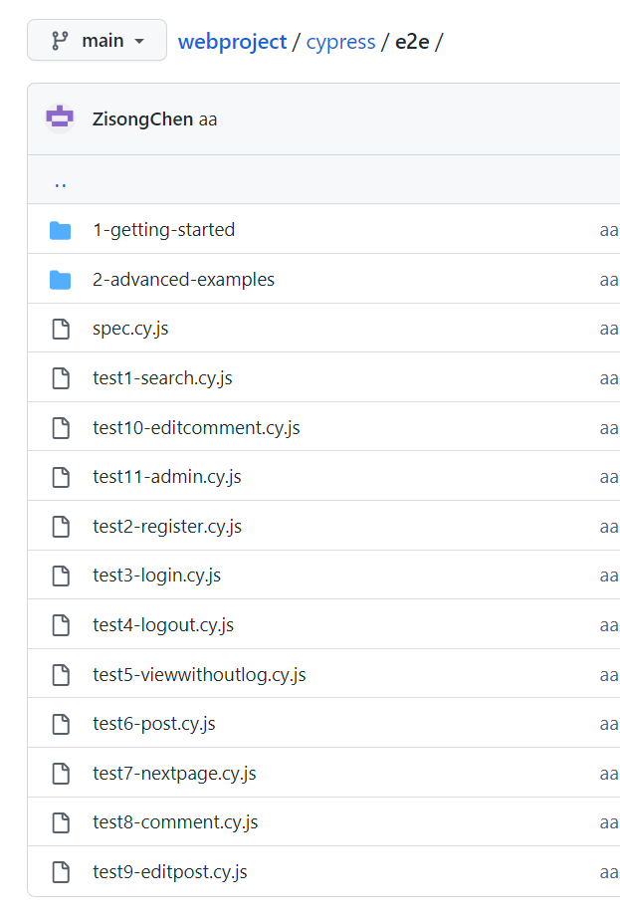

Sum=25+5+4+5=39



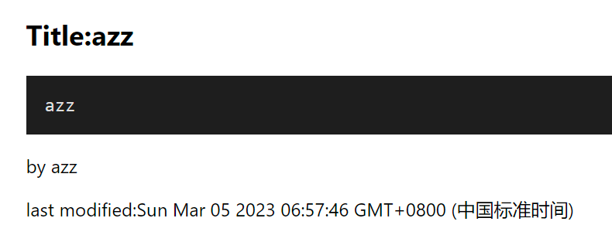 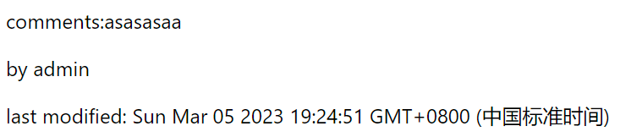

You can see the timestamp of last modified in this the bottom of post and comment

Sum=25+5+4+5+2=41



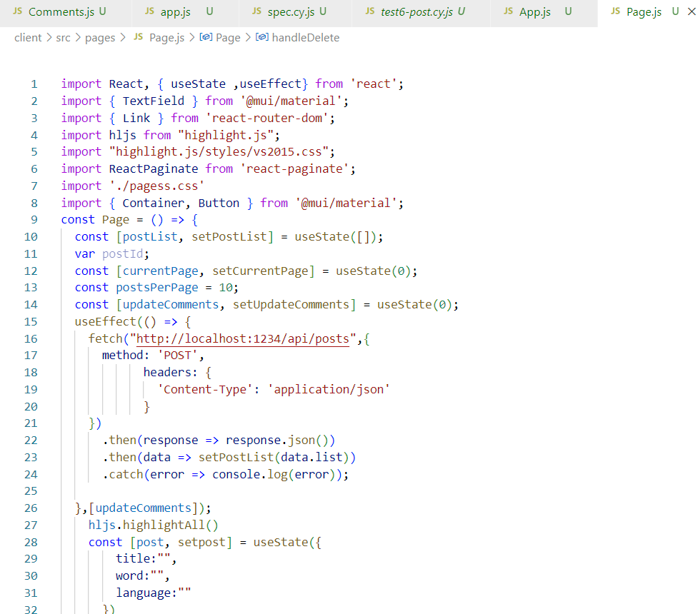

You can see my use of highlight in Page.js and the result of the use is:

this thing in post.

And when you turn to next page or add a new post ,you need to refresh the page to see the use of highlight or type something here :

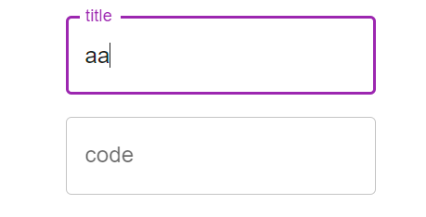In this way the page will reuse the highlight to render the code.

Sum=25+5+4+5+2+2=43



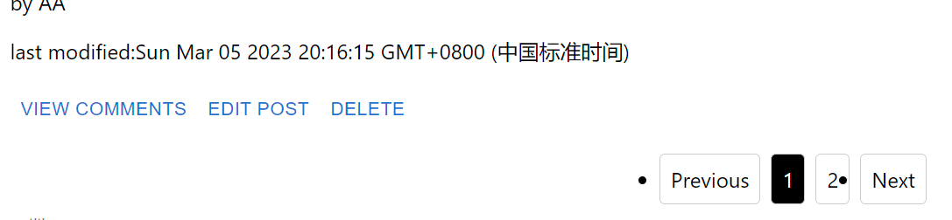

When the number of your post is larger than 10, another page will appear, you can press “2” or “next” to go to next page(Remember to press the word ”Previous” “Next” excatly)

Sum=25+5+4+5+2+2+2=45



When you login with admin account (email:”admin”,password:”admin”), You can go to edit all posts and comment as above mentioned ways and you can delete them by “press” delete button ,then



The post or comment will disappear, and when you delete the post, all related comments will be delete as well:

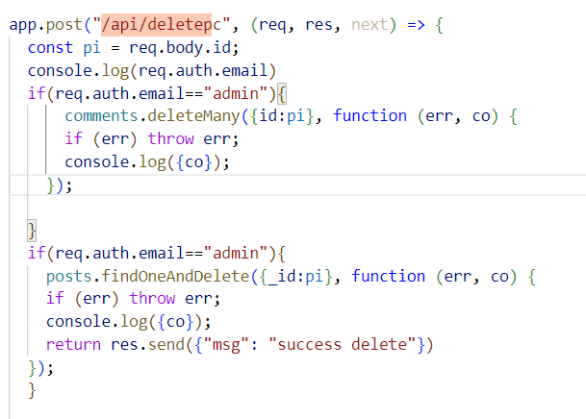

And if you are not login with admin account, nothing will happen when you press “delete” button

Sum=25+5+4+5+2+2+2+3=48



You need to use keyboard to type things to comment or post.

You can click with mouse to click different button

You can use screen to do the click

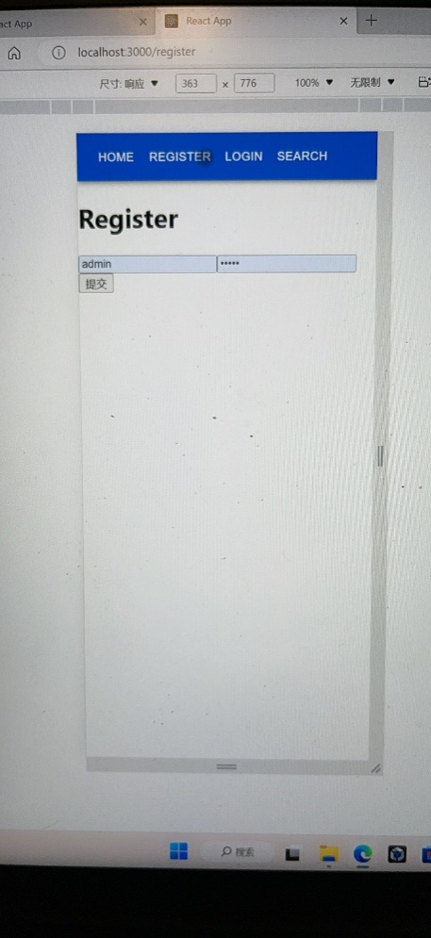

Sum=25+5+4+5+2+2+2+3+3=51





Click the search button in the header. Type the word you want to search and click search button in the page. Now you can see the related posts who have words in title or code

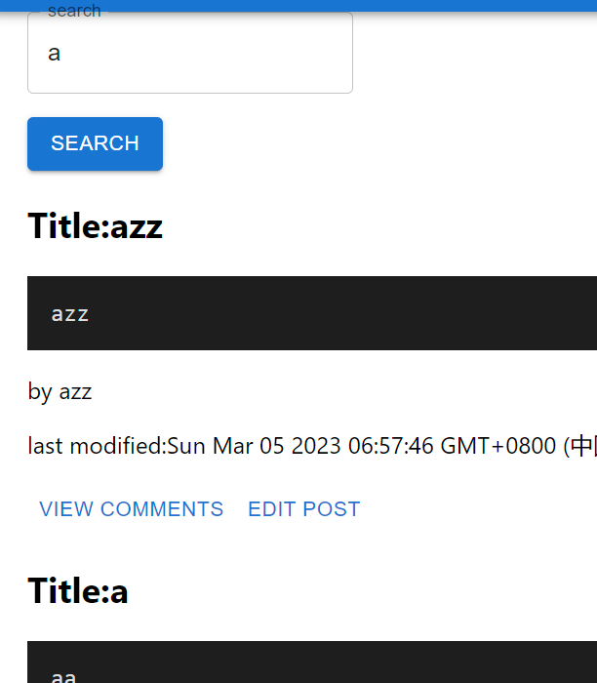

Sum=25+5+4+5+2+2+2+3+3+2=53